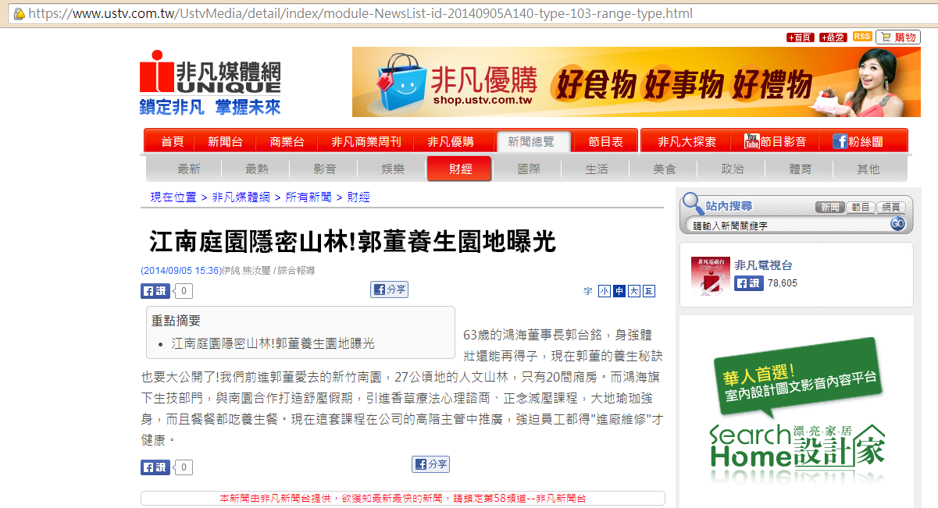

影像露出連結
https://www.youtube.com/watch?v=R3cymcDl0KU

